**Stroop Effect experiment data analysis**

**Project discription**

This project analysed a dataset from a Stroop Effect experiment.

Detailed information about this experiment: [https://faculty.washington.edu/chudler/words.html#seffect](https://faculty.washington.edu/chudler/words.html%23seffect)

The dataset from: <https://drive.google.com/file/d/0B9Yf01UaIbUgQXpYb2NhZ29yX1U/view>

**Independent variable and Dependent variable**

The independent variable is the wordset used in the test

The dependent variable is the total time that participants used for a wordset.

**Hypotheses**

Null Hypotheses(H0): MD = 0

Time difference for Congruent wordset and Incongruent wordset is 0.

Aterlative Hypotheses(H1) : MD ≠0

Time difference for Congruent wordset and Incongruent wordset is not 0.

**Statistical test**

This is a two-tailed dependent test (no direction is predicted)

**Descriptive statistics**

Table 1

*Results of Descriptive Statistics for Stroop Effect Experiment.*

|  |  |  |  |  |  |  |  |  |  |  |
| --- | --- | --- | --- | --- | --- | --- | --- | --- | --- | --- |
| Congruent | | |  | Incongruent | | |  | Difference | | |
| M | SD | n |  | M | SD | n |  | MD | SD | n |
| 14.05 | 3.56 | 24 |  | 22.02 | 4.8 | 24 |  | 7.96 | 4.86 | 24 |

Figure 1

*Histogram of time difference between Congruent test and Incongruent test.*

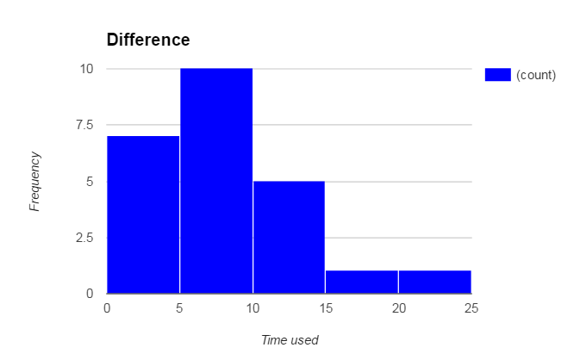

This is a positive skewed distribution

**T-test**

Table 1

*Results of T test for Stroop Effect Experiment.*

|  |  |  |  |  |
| --- | --- | --- | --- | --- |
| Mean of Difference  M | SE | t-value | t-critical | df |
| 7.96 | 0.99 | 8.02 | 2.064* | 23 |

*p< .05

Results of the t-test show a statistically significant mean difference between Congruent test and Incongruent test, null hypothese rejected, participants tend to spend more time in naming colors for Incongruent wordset.